**Two critical Bugs:**

1. Bug title: Missing author value on the comments list page

Test env: production

Test link: <https://buggy.justtestit.org/model/c0bm09jgagshpkqbsv00%7Cc0bm09jgagshpkqbsv2g>

Priority: 2

Severity: 3

Found in build: V1.0.0

Tested by: Miranda Dong

Assigned to:

Linked user story: 123457

Repro step:

1. Given I am home page
2. Then I Click Overall Rating
3. And I Click the top car image
4. Then I can see the list of comments

Actual result: Authors are not listed comments

Expected result: Authors are listed comments,

Screenshot:

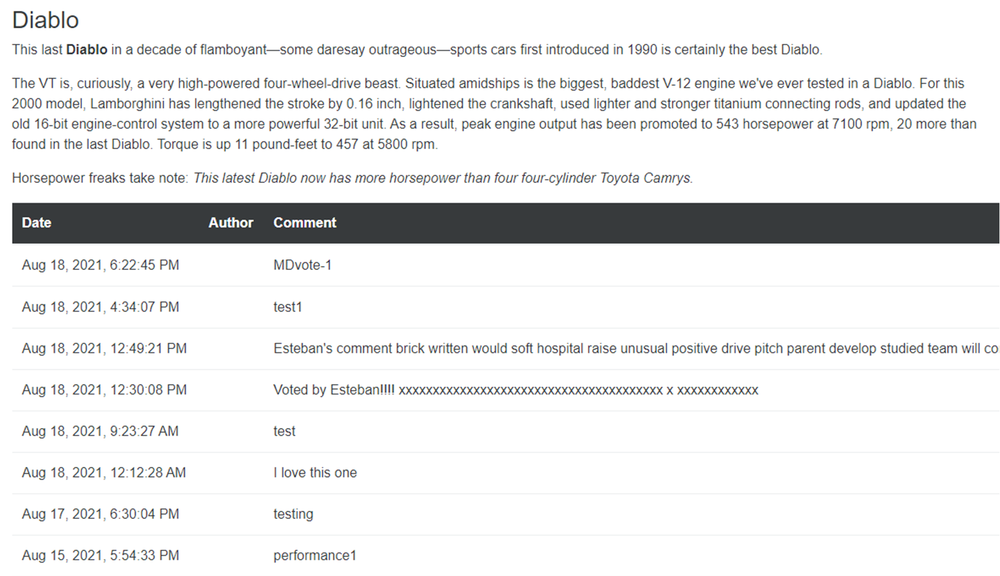

1. Bug title: Split the page

Test env: production

Test link: <https://buggy.justtestit.org/model/c0bm09jgagshpkqbsv00%7Cc0bm09jgagshpkqbsv2g>

Priority: 2

Severity: 3

Found in build: V1.0.0

Tested by: Miranda Dong

Assigned to:

Linked user story: 123456

Repro step:

1. Given I am home page
2. Then I Click Overall Rating
3. And Click the top car image
4. Then I can see the list of comments

Actual result: All the comments are listed in one page

Expected result: Comments should be split into multi page.

Screenshot:

